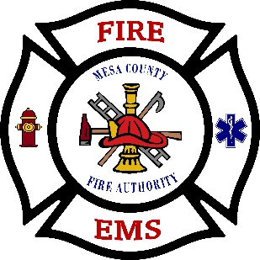
Mesa County Fire Authority
Fire Chief’s Report

August 25, 2026
Prepared By: Charles K. Balke, Fire Chief

Comments from the Fire Chief
I continue to work with the staff on improvements within the organization.

Administrative Update
- I have generated a draft RFP for the Boards’ review and comment for the repair to the station apparatus apron at Station 53.
- I have generated a draft RFP for the Boards’ review for apparatus bay lighting replacement at both stations.
- We are still working on creating a fleet fuel account at the Golden Gate in Whitewater. The intention is to have a business with Fleet Fuel capabilities within our own jurisdiction for our apparatus and support local business.
- Continue to work with Mesa County Building Department on the process for evaluating and ground truthing process for the Wildfire Resiliency Code.
- I flew to Dacatur Illinois to pick up and drive the new Pumper/Tender back. Spent time with their agency to get in-service training on the apparatus.

Personnel Update
- Based on the pending consideration of Clifton Fire Protection District, assuming organizational leadership all applications have been suspended.

Training Update
- The Hazardous Materials Course has been scheduled with a start date of September 14, 2026 and will be completed on October 11, 2026. This will be a hybrid course consisting of online didactic discussions and hands-on practical skills demonstration.
- We have had training on the new Pumper/Tender

Apparatus/Equipment/Facility Update
- Tender 51 has been sent in for DOT inspection, pump and general maintenance repairs.
- Ladder Testing was completed. All ladders passed.
- Working with ROI to schedule SCBA flow testing and SCBA Fit Testing.

Miscellaneous
- The SAFER Grant for Volunteer Recruitment and Retention committee selected a grant coordinator. If successful, the coordinator will administer the grant and work with each agency’s representative for funding reimbursements.

Operations
I have updated the response numbers through the end of July and will provide whole numbers from the preceding month versus incomplete data for the current month. During the meeting I will provide the updated year-to-date call count.
- For the month of July there were 38 incidents. This is a decrease of 6 calls compared to the same time last year. For the same period in 2026 there have been 222 incidents, a decrease of 15 calls for the same time last year.

Reports
